Insert School Logo | Insert School Name

Semester 1 Examination 2010

Question/Answer Booklet

MATHEMATICS 3C

Section One

(Calculator Free)
Your name

Time allowed for this section
Reading time before commencing work: 5 minutes
Working time for paper: 50 minutes

Material required/recommended for this section

To be provided by the supervisor
Question/answer booklet for Section One.
Formula sheet.

To be provided by the candidate
Standard items: pens, pencils, pencil sharpener, highlighter, eraser, ruler.
Important note to candidates
No other items may be taken into the examination room. It is your responsibility to ensure that you do not have any unauthorised notes or other items of a non-personal nature in the examination room. If you have any unauthorised material with you, hand it to the supervisor before reading any further.

Structure of this examination

 | Number of questions | Working time (minutes) | Marks available
This Section (Section 1)  Calculator Free | 7 | 50 | 40
Section Two  Calculator Assumed | 12 | 100 | 80
Total marks |  |  | 120

Instructions to candidates

- The rules for the conduct of WACE external examinations are detailed in the booklet WACE Examinations Handbook. Sitting this examination implies that you agree to abide by these rules.

- Answer the questions in the spaces provided.

- Spare answer pages are provided at the end of this booklet. If you need to use them, indicate in the original answer space where the answer is continued i.e. give the page number.

- Show all working clearly. Any question, or part question, worth more than 2 marks requires valid working or justification to receive full marks. If you repeat an answer to any question, ensure that you cancel the answer you do not wish to have marked.
Section One (calculator-free) 40 Marks
This section has five (5) questions. Answer all questions. Write your answers in the space provided.

Spare pages are included at the end of this booklet. They can be used for planning your responses and/or as additional space if required to continue an answer.
  - Planning: If you use the spare pages for planning, indicate this clearly at the top of the page.
  - Continuing an answer: If you need to use the space to continue an answer, indicate in the original answer space where the answer is continued, i.e. give the page number. Fill in the number of the question(s) that you are continuing to answer at the top of the page.

Suggested working time for this section is 50 minutes.

Question 1 (4 marks)
A function g(x) has a y intercept of 3 at point A. Find the image of point A under the following transformation:
(a) 2g(x) − 1 (1 mark)

(b) −g(3x + 6) + 4 (3 marks)

Question 2 (7 marks)
(a) Express with a common denominator and simplify
$\frac{2}{3x−5}−\frac{1}{3x+5}$ (3 marks)

(b) Simplify: $\frac{6x^{2}−6}{x^{2}−x−6}¸\frac{9x^{2}−9x}{x^{2}−2x−3}$ (4 marks)
Question 3 (5 marks)
For each of the following find the derivative with respect to x:
(a) $\left(3e^{5}−(3x+p)(2e^{4x})\right)$ (2 marks)

(b) $\frac{\sqrt{7−x^{4}}}{x}$ (Do not simplify your answer but express your answer with
positive exponents) (3 marks)

Question 4 (4 marks)
(a) $\int{e^{4−3x}}\text{dx}$ (1 mark)

(b) $\int_{−1}^{a}{(2x^{2}−x^{6}})(3x^{5}−2x)\text{dx}$ (3 marks)

Question 5 (7 marks)
The graph of a function p is given on the right. p is defined only in the interval 0 ≤ x ≤ 4, zero elsewhere and is symmetrical about the turning point (2, b). Also $\int_{0}^{4}{p(x)\text{dx}}$ = 1 | 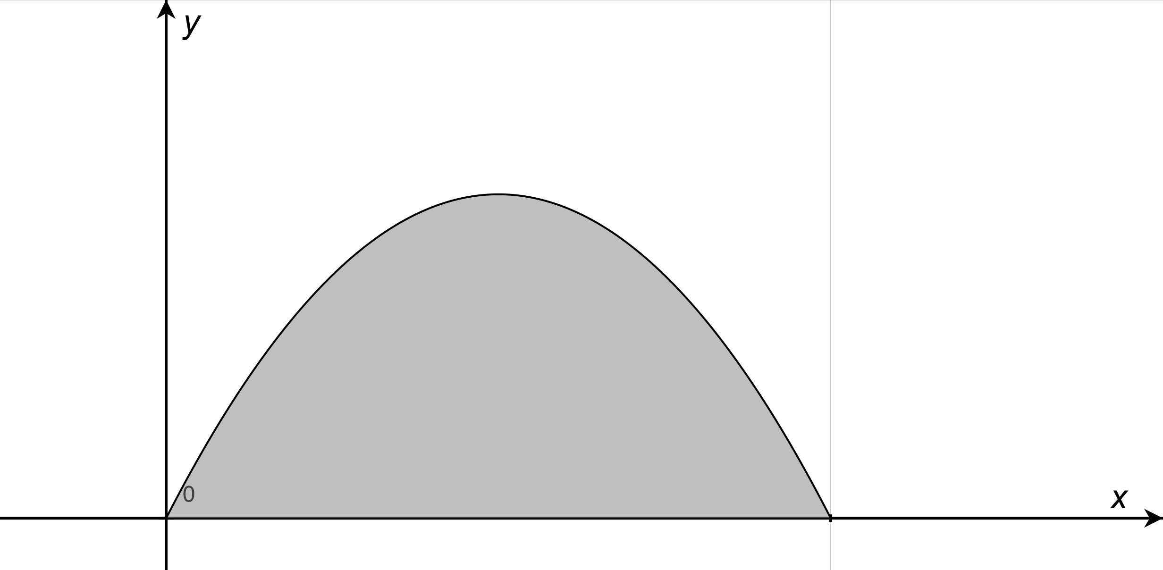

(a) Could p represent a probability density function? Explain your answer. (1 mark)

(b) Determine
(i) $\int_{0}^{4}{p(−x)\text{dx}}$ (1 mark)

(ii) $\int_{−2}^{2}{2p(x)\text{dx}}$ (2 marks)

(iii) $\int_{0}^{4}{(e^{−2x}+p(x))\text{dx}}$ (3 marks)

Question 6 (4 marks)
Joe has calculated the arrival time of his girlfriend on any date can be modeled by a uniform probability function with a maximum arrival time of 30 minutes. If this probability function provides a good estimate of future events, determine the probability on the next date, Joe will wait:
(a) exactly 20 minutes (1 mark)

(b) at least 25 minutes (1 mark)

(c) at least 25 minutes if he has to wait at least 10 minutes. (2 marks)

Question 7 (9 marks)
P(A) = 0.2, P(B) = x and P(A ∪ B) = p.
(a) Find in terms of x, p and/or any numeric value
(i) P(A ∩ B) (1 mark)

(ii) P($\overline{A}$ ∪ B) (2 marks)

(b) If event A is a subset of event B determine a numeric range of values for p. (1 mark)

(c) If x = 0.6, determine for what values of p are
(i) events A and B mutually exclusive? (2 marks)

(ii) events A and B are independent? (3 marks)
Additional working space

Additional working space

Section One (calculator-free) 40 Marks
This section has five (5) questions. Attempt all questions.
Working time: 50 minutes

Question 1 (4 marks)
A function g(x) has a y intercept of 3 at point A. Find the image of point A under the following transformation:
(a) 2g(x) − 1 (1 mark)

A’(0, 5) √

(b) −g(3x + 6) + 4 (3 marks)

−g(3(x + 2)) + 4 √

A’(−2, 1) √ √ One mark for each abscissa and ordinate value

Question 2 (7 marks)
(a) Express with a common denominator and simplify
$\frac{2}{3x−5}−\frac{1}{3x+5}$ (3 marks)

$\frac{2(3x+5)−1(3x−5)}{(3x−5)(3x+5)}$ √

$\frac{6x+\text{10}−3x+5}{(3x−5)(3x+5)}$ √

$\frac{3x+\text{15}}{(3x−5)(3x+5)}$ √

(b) Simplify: $\frac{6x^{2}−6}{x^{2}−x−6}¸\frac{9x^{2}−9x}{x^{2}−2x−3}$ (4 marks)

$\frac{6(x−1)(x+1)}{(x−3)(x+2)}´\frac{(x−3)(x+1)}{9x(x−1)}$ √ √ √

$\frac{2(x+1)^{2}}{3x(x+2)}$ √
Question 3 (5 marks)
Find in each of the following find the derivative with respect to the indicated variable:
(a) $\left(3e^{5}−(3x+p)(2e^{4x})\right)$ (2 marks)
−6e^{4x} − 8e^{4x}(3x + π) √ √

(b) $\frac{\sqrt{7−x^{4}}}{x}$ (Do not simplify your answer but express your answer with
positive exponents) (3 marks)

$\frac{\frac{1}{2}(7−x^{4})^{−\frac{1}{2}}(−4x^{3})x−1´\sqrt{7−x^{4}}}{x^{2}}$ √ √

$\frac{\frac{−2x^{4}}{\sqrt{7−x^{4}}}−\sqrt{7−x^{4}}}{x^{2}}$ √

Question 4 (4 marks)

(a) $\int{e^{4−3x}}\text{dx}$ (1 mark)

$\frac{e^{4−3x}}{−3}+c$ √

(b) $\int_{−1}^{a}{(2x^{2}−x^{6}})(3x^{5}−2x)\text{dx}$ (3 marks)
$\frac{{\left(2x^{2}−x^{6}\right)}^{2}}{−4}]_{−1}^{a}$ √ √

$\frac{{\left(2a^{2}−a^{6}\right)}^{2}}{−4}+\frac{1}{4}$

Question 5 (7 marks)
The graph of a function p is given on the right. p is defined only in the interval 0 ≤ x ≤ 4, zero elsewhere and is symmetrical about the turning point (2, b). Also $\int_{0}^{4}{p(x)\text{dx}}$ = 1

(a) Could p represent a probability density function? Explain your answer. (1 mark)
Yes. The curve is above the x axis (ie p(x) ≥ 0 for 0 ≤ x ≤ 4) and $\int_{0}^{4}{p(x)\text{dx}}$ = 1 √

(b) Determine
(i) $\int_{0}^{4}{p(−x)\text{dx}}$ (1 mark)

0 √

(ii) $\int_{−2}^{2}{2p(x)\text{dx}}$ (2 marks)

1 √ √

(iii) $\int_{0}^{4}{(e^{−2x}+p(x))\text{dx}}$ (3 marks)
$\int_{0}^{4}{e^{−2x}}\text{dx}+\int_{0}^{4}{p(x)\text{dx}}$ √
$\frac{e^{−2x}}{−2}]_{0}^{4}+1$ √
$\frac{e^{−8}}{−2}+\frac{3}{2}$ √

Question 6 (4 marks)
Joe has calculated the arrival time of his girlfriend on any date can be modeled by a uniform probability function with a maximum arrival time of 30 minutes. If this probability function provides a good estimate of future events, determine the probability on the next date, Joe will wait:
(a) 20 minutes (1 mark)

0 √

(b) at least 25 minutes (1 mark)

$\frac{1}{6}$

(c) at least 25 minutes if he has to wait at least 10 minutes. (2 marks)

$\begin{aligned}P(\text{X }³\text{ 25}|\text{ X }³\text{ 10})=\frac{P(\text{X }³\text{ 25})}{P(\text{X }³\text{ 10})} \\ \frac{\frac{1}{6}}{\frac{2}{3}}=\frac{1}{4} \\ \end{aligned}$√ √
Question 7 (9 marks)
P(A) = 0.2, P(B) = x and P(A ∪ B) = p.
(a) Find in terms of x, p and/or any numeric value
(i) P(A ∩ B) (1 mark)

0.2 + x − p √

(ii) P($\overline{A}$ ∪ B) (2 marks)

1 + x − p (a Venn diagram would assist) √ √

(b) If event A is a subset of event B determine a numeric range of values for p. (1 mark)

0.2 ≤ p ≤ x √

(c) If x = 0.6, determine for what values of p are
(i) events A and B mutually exclusive? (2 marks)

P(A ⩂ B) = P(A) + P(B) √
p = 0.2 + 0.6 = 0.8 √

(ii) events A and B are independent? (3 marks)

P(A ⩃ B) = P(A) × P(B) √
0.2 + x − p = 0.2 × x √
0.8 − p = 0.12
p = 0.68 √

